

Amity School Of Engineering and Technology
Department of Information and Technology
REPORT

Restaurant Management System(EatSmart)

INTEGRATED PROJECT Semester - 06
Mahesh Yadav (A2305323067)
Tejendra Singh Kushwah (A2305323079)
Harmanjyot Singh (A2305323077)
Sparsh Teotia (A2305323008)
Program: B. Tech IT (2023-27)

ABSTRACT

The food service industry is evolving rapidly, and traditional restaurant management systems often fail to address modern challenges such as food waste, long waiting times, and inefficient table management. This project, "EatSmart – Restaurant Management System", is a comprehensive web-based platform developed to modernize the dining experience by integrating smart reservation management, real-time order tracking, pre-ordering, and a food waste reduction module into a single cohesive system.

The system is built using HTML, CSS, JavaScript, and PHP with a MySQL database backend. It provides a dual-interface solution — a customer-facing web application and an admin/kitchen management panel. Customers can browse the menu, reserve tables with specific time slots, pre-order meals before arrival, and track their order status live from accepted to delivered. The admin panel provides complete control over menu management, order processing, reservation handling, and sales analytics.

A key differentiator of EatSmart is its Food Waste Reduction Module, where admin staff can mark surplus food at discounted prices, encouraging customers to purchase it before it goes to waste. The system also incorporates AI-driven features including a popular dish recommender based on order history, a day-of-week demand prediction model, and a rule-based intelligent chatbot that handles over 15 customer query types. The kitchen display board auto-refreshes to give live order visibility to kitchen staff, while the live order tracker gives customers real-time status updates every 8 seconds.

OBJECTIVE

The primary objective of this project is to design and develop a fully functional, intelligent restaurant management web application that streamlines operations for both customers and restaurant administrators. The specific objectives are:

- To provide customers with an intuitive platform to browse the menu, make table reservations with time slots, and pre-order food before arrival, thereby eliminating waiting time and improving the dining experience.

- To implement a real-time live order tracking system that automatically updates order status from received to accepted, cooking, ready, and delivered.

- To develop a unique Food Waste Reduction Module that allows admin staff to list surplus food items at discounted prices, promoting sustainability and reducing restaurant food waste.

- To build a comprehensive Admin Dashboard with full control over menu management, order status updates, reservation management, and customer analytics.

- To integrate a Kitchen Display Board that auto-refreshes every 15 seconds providing kitchen staff with a real-time view of all active orders.

- To incorporate AI features including a popular dish recommender, a demand prediction model based on historical day-of-week data, and a rule-based intelligent chatbot.

- To implement a loyalty points system that rewards customers for repeat orders, enhancing customer retention.

- To ensure system security through PHP session-based authentication, bcrypt password hashing, and SQL injection prevention via prepared statements.

INTRODUCTION

The restaurant industry faces numerous operational challenges including inefficient table management, long customer wait times, high food waste, and poor communication between front-of-house and kitchen staff. Traditional management methods relying on manual processes are insufficient for modern dining expectations, where customers demand convenience, speed, and transparency.

EatSmart is a smart, web-based Restaurant Management System designed to address these challenges through an integrated digital platform. Built using core web technologies — HTML5, CSS3, JavaScript, and PHP with MySQL — the system is accessible on any device through a standard web browser without requiring additional installations.

The system serves two primary user groups: customers and restaurant administrators. Customers interact through a polished, mobile-responsive interface to browse menus by category, reserve tables, place pre-orders, track live order status, and take advantage of waste reduction deals. Administrators and kitchen staff use a dedicated dashboard to manage every aspect of restaurant operations in real time.

What makes EatSmart stand out from conventional systems is its combination of operational features with intelligent, data-driven modules. The AI recommender suggests popular dishes based on order count. The demand prediction feature forecasts which dishes are likely to sell more on a given day of the week. The rule-based chatbot handles common customer queries instantly. Together, these features create a system that is not just a management tool but a smart operational partner for the modern restaurant.

LITRATURE REVIEW

The development of digital solutions for restaurant management has been an active area of research and commercial development in recent years. Traditional restaurant POS (Point-of-Sale) systems, while functional, are largely limited to billing and inventory management and do not address the broader customer experience or sustainability concerns.

Research on online food ordering systems highlights the importance of real-time communication between customers and kitchen staff. Studies on platforms such as Zomato and Swiggy demonstrate the effectiveness of digital ordering but note that these platforms operate as aggregators rather than integrated restaurant management systems. They lack features like in-restaurant pre-ordering, live kitchen status boards, and direct waste management.

The concept of food waste reduction through technology has gained significant attention. According to the Food and Agriculture Organization (FAO), approximately one-third of all food produced globally is wasted. Several academic papers have proposed dynamic pricing models for near-expiry food, similar to EatSmart's Waste Reduction Module, as an effective strategy for reducing surplus food waste in food service establishments.

In the domain of recommendation systems, frequency-based models have been widely used in e-commerce. The approach adopted in EatSmart — ranking menu items by cumulative order count — aligns with content-based frequency analysis, which has been validated in multiple restaurant recommendation studies as an effective baseline method requiring minimal computational resources.

Rule-based chatbots have been documented extensively as practical solutions for customer service automation in hospitality. Unlike NLP-based models that require large training datasets, rule-based systems offer predictability and ease of maintenance — making them well-suited for a restaurant environment where query types are limited and well-defined.

METHODOLOGY

The development of EatSmart followed a structured, phase-based approach covering system design, database architecture, frontend and backend development, AI module integration, and testing.

Phase 1 – Requirement Analysis and System Design:
The initial phase involved identifying core requirements through analysis of restaurant operational pain points. Key user stories were defined for both customer and admin roles. A system architecture was designed consisting of a PHP backend, MySQL database, HTML/CSS/JS frontend, and a shared includes system for reusable components. The project structure was organized into logical directories for CSS, JavaScript, PHP, admin, and includes.

Phase 2 – Database Design and Implementation:
A normalized MySQL database schema was designed with 8 core tables: users, categories, menu_items, restaurant_tables, reservations, orders, order_items, and waste_deals. Foreign key relationships were established between tables to maintain referential integrity. The database was seeded with realistic sample data including 21 menu items across 6 categories, 10 restaurant tables, and 4 user accounts for testing purposes.

Phase 3 – Frontend Development:
The customer-facing interface was built using semantic HTML5, a custom CSS design system with CSS variables for consistent theming, and vanilla JavaScript. The design uses Google Fonts (Playfair Display for headings, DM Sans for body text). Key frontend features include a persistent cart sidebar using localStorage, an animated order status tracker, deal countdown timers, and a floating chatbot widget.

Phase 4 – Backend PHP Development:
The backend was developed in PHP with a centralized config.php providing database connection, session management, and authentication helpers. All database interactions use MySQLi prepared statements. Password hashing uses PHP's password_hash() with bcrypt. Session-based authentication supports three roles: customer, admin, and kitchen.

Phase 5 – Admin Panel and AI Integration:
The admin panel includes a real-time dashboard, order management with status update modals, menu manager, reservation manager, waste deals manager, and sales reports. Three AI modules were integrated: the Popular Dish Recommender aggregates order_items by menu_item_id, the Demand Prediction module groups historical orders by day of week, and the Rule-Based Chatbot uses JavaScript keyword matching for 15+ intent categories.

RESULT

The completed EatSmart system delivers a fully functional, multi-user restaurant management web application. The following modules were implemented and tested successfully:

1. Customer Interface & Menu System
The customer-facing homepage presents live statistics, featured popular dishes, and active waste deals. The full menu page supports category filtering across 6 categories and real-time search. Items can be added to a persistent cart sidebar that calculates subtotal, 5% GST, and grand total automatically using localStorage.
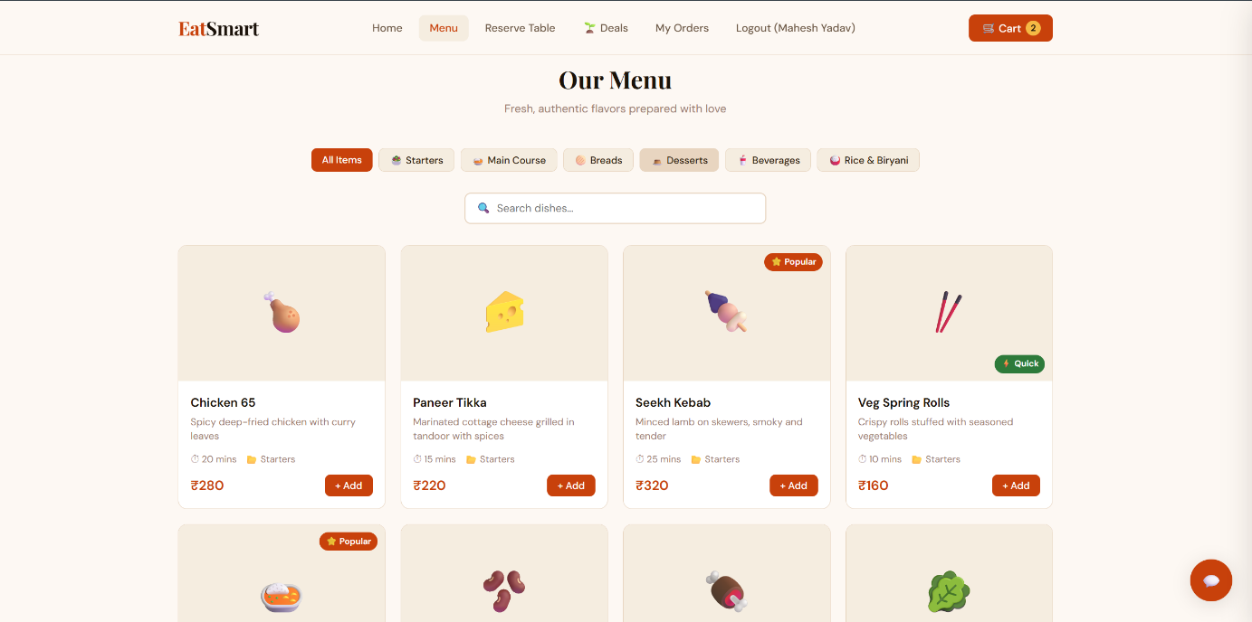
2. Table Reservation with Time Slot System
Customers can reserve tables by selecting a date, guest count, time slot, and table. The system queries the database in real time to mark already-booked slots as unavailable, preventing double-booking. Tables are filtered by capacity based on guest count. Reservations appear in the My Reservations page with cancel functionality.
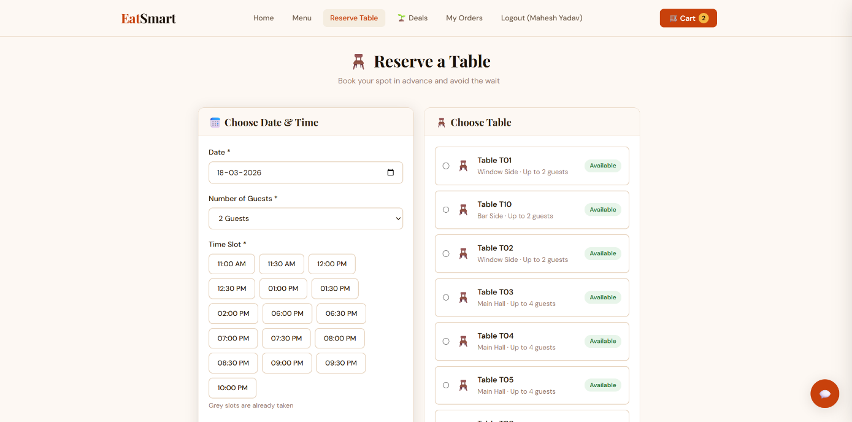
3. Pre-Order & Live Order Tracking
Customers can pre-order food before arrival through the checkout system. The My Orders page displays a 5-step order tracker (Received → Accepted → Cooking → Ready → Delivered) that auto-refreshes every 8 seconds by polling the PHP status API, providing live visibility without requiring page refresh.
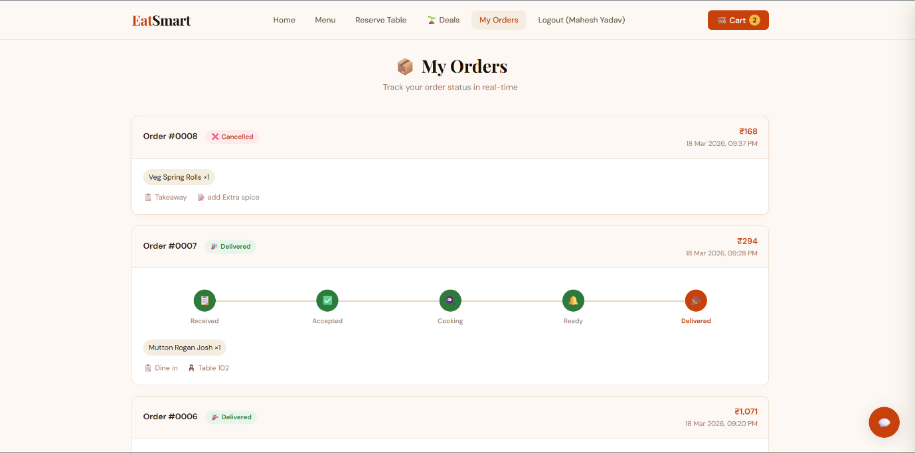
4. Food Waste Reduction Module
The Waste Deals page lists surplus food items marked by admin at discounted prices with live countdown timers. The discount percentage and savings amount are clearly displayed. Admins create deals from the admin panel, selecting a menu item, discounted price, quantity, and expiry duration. The system automatically calculates discounts and prevents duplicates.
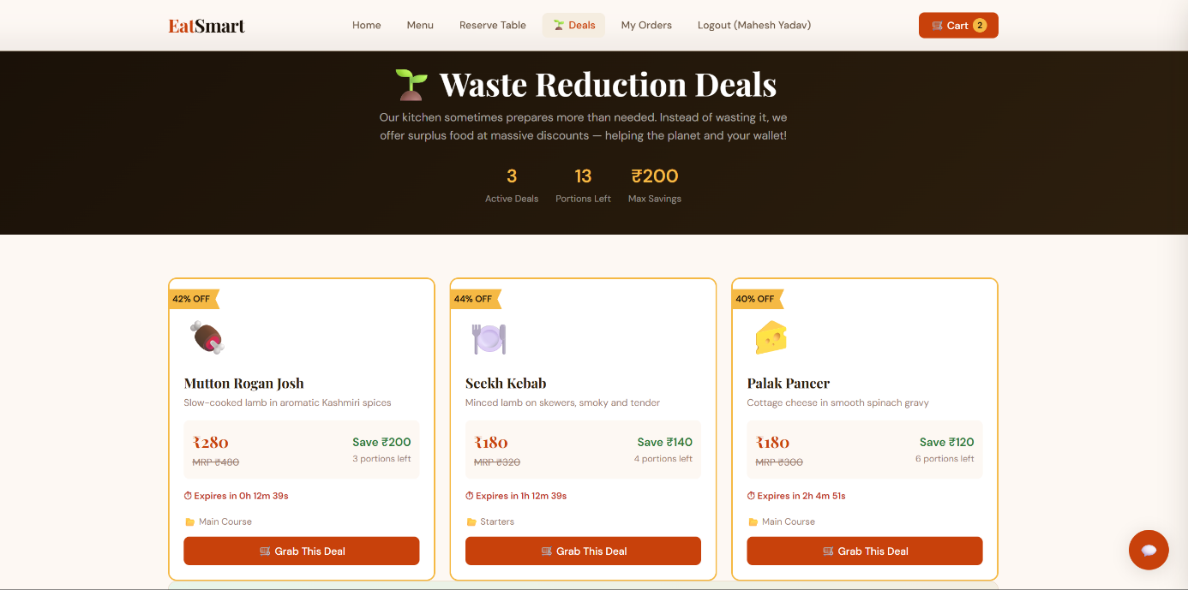
5. Admin Dashboard & Kitchen Board
The admin dashboard displays real-time statistics with an animated weekly revenue chart and AI-powered top dishes chart. The Kitchen Display Board presents active orders in a Kanban-style 4-column layout (New → Accepted → Cooking → Ready) with one-click status advancement and auto-refresh every 15 seconds.
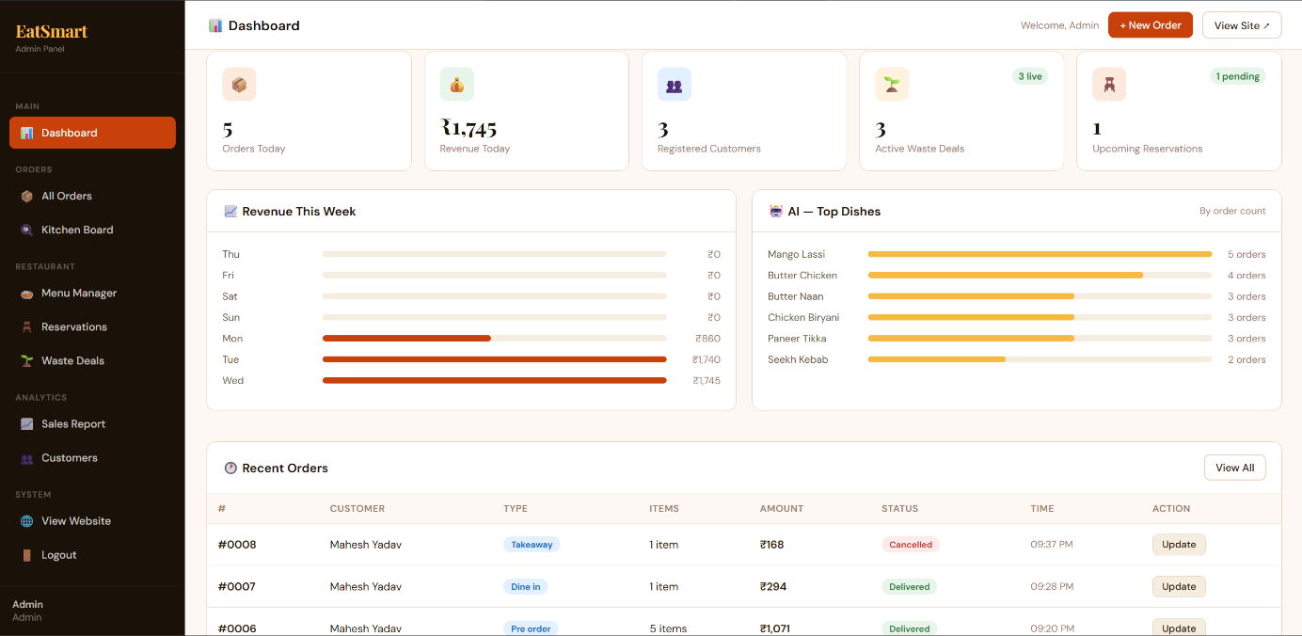
6. AI Features – Recommender, Demand Prediction & Chatbot
The Popular Dish Recommender displays the top 5 most-ordered dishes based on cumulative order count. The Demand Prediction module forecasts high-demand dishes for the current day of week from historical data. The rule-based chatbot handles 15+ query types including menu enquiries, reservation help, deal information, order tracking, and restaurant information.
